emvedded linux develment of rasberry pi(confirgurationa nd all)
Embedded Linux Development on Raspberry Pi (Configuration & Setup)
1. What is Embedded Linux?
Embedded Linux is a customized Linux operating system running on embedded hardware such as a Raspberry Pi. It allows developers to build applications, device drivers, and complete embedded systems.

2. Raspberry Pi Hardware Overview
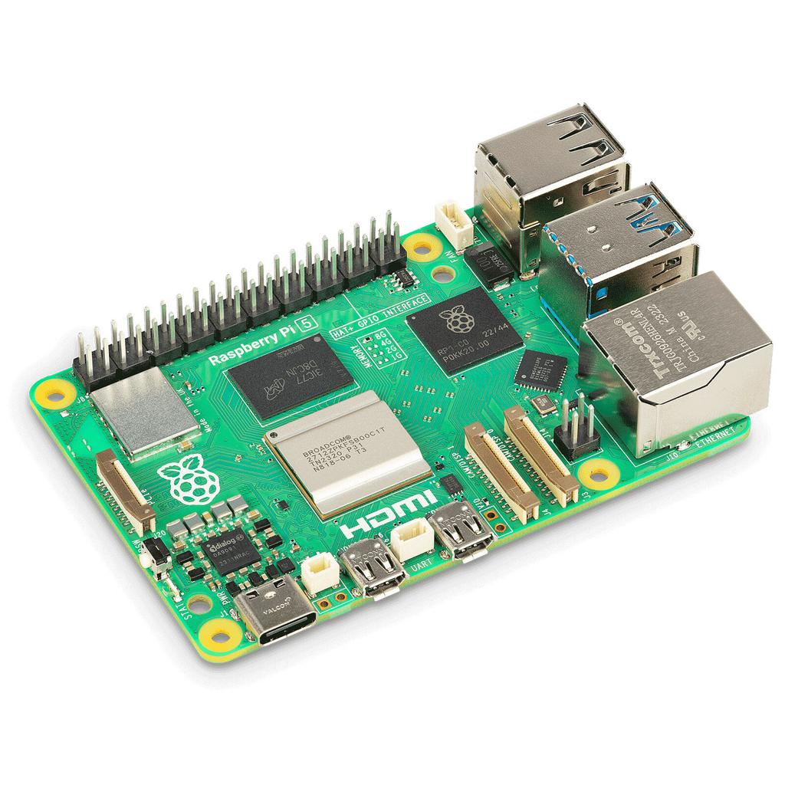
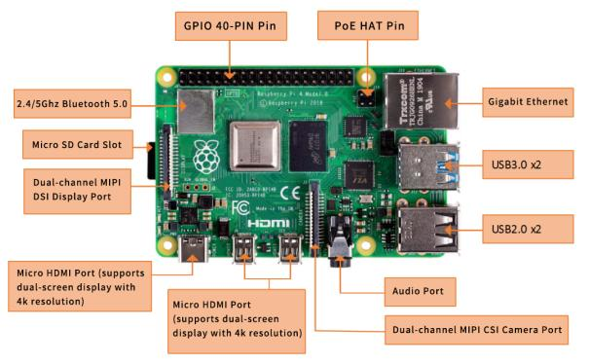
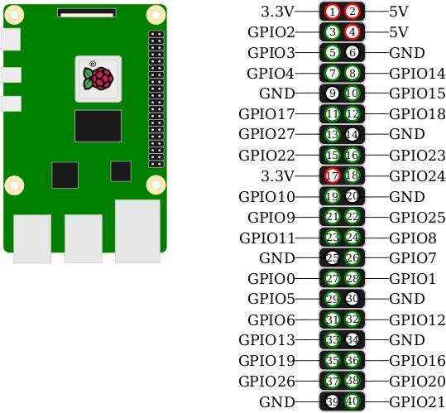
5
A Raspberry Pi consists of:
- SoC (System on Chip) – CPU, GPU, memory controller
- RAM
- GPIO pins
- USB ports
- Ethernet/Wi-Fi
- SD card storage
- HDMI display interface
Common models:
Model | CPU
Raspberry Pi 3 Model B | ARM Cortex-A53
Raspberry Pi 4 Model B | ARM Cortex-A72
Raspberry Pi 5 | ARM Cortex-A76

3. Development Environment Setup
Method 1: Native Development
Compile programs directly on Raspberry Pi.
sudo apt update
sudo apt install build-essential git
Compiler:
gcc hello.c -o hello
./hello

Method 2: Cross Compilation
Compile on PC and run on Pi.
Example toolchain:
arm-linux-gnueabihf-gcc
Compile:
arm-linux-gnueabihf-gcc hello.c -o hello
Transfer:
scp hello pi@192.168.1.10:/home/pi
Run:
./hello

4. Raspberry Pi OS Installation
Download Raspberry Pi OS
Use:
Raspberry Pi Imager
Steps:
- Insert SD card.
- Open Raspberry Pi Imager.
- Select OS.
- Select Storage.
- Write image.

5. First Boot Configuration
After boot:
sudo raspi-config
Configure:
- Hostname
- Password
- SSH
- Wi-Fi
- Locale
- Timezone
- Camera
- SPI
- I2C
- Serial Interface

6. Network Configuration
Check IP:
ip addr
Ping test:
ping google.com
Enable SSH:
sudo systemctl enable ssh
sudo systemctl start ssh
Connect from PC:
ssh pi@<ip-address>

7. GPIO Development
Install GPIO library:
sudo apt install gpiod
GPIO commands:
gpioinfo
gpioget gpiochip0 17
gpioset gpiochip0 17=1

8. Device Tree
Device Tree describes hardware to Linux.
Location:
/boot/firmware/
Files:
*.dtb
Compile:
dtc -I dts -O dtb file.dts -o file.dtb

9. Kernel Configuration
Download kernel:
git clone --depth=1 https://github.com/raspberrypi/linux
Configure:
make menuconfig
Build:
make -j4
Important options:
- Device Drivers
- Networking
- Filesystems
- USB Support
- I2C
- SPI
- GPIO

10. Boot Process
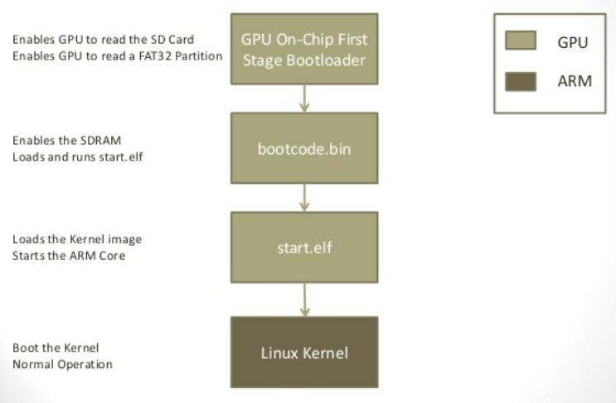
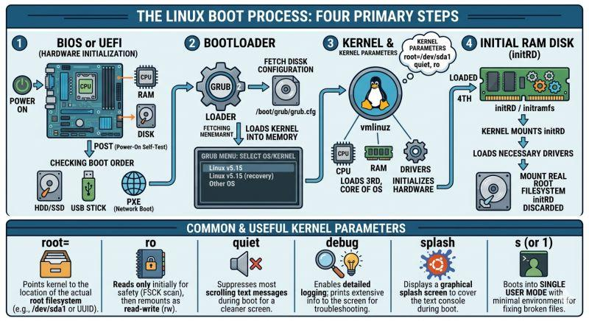
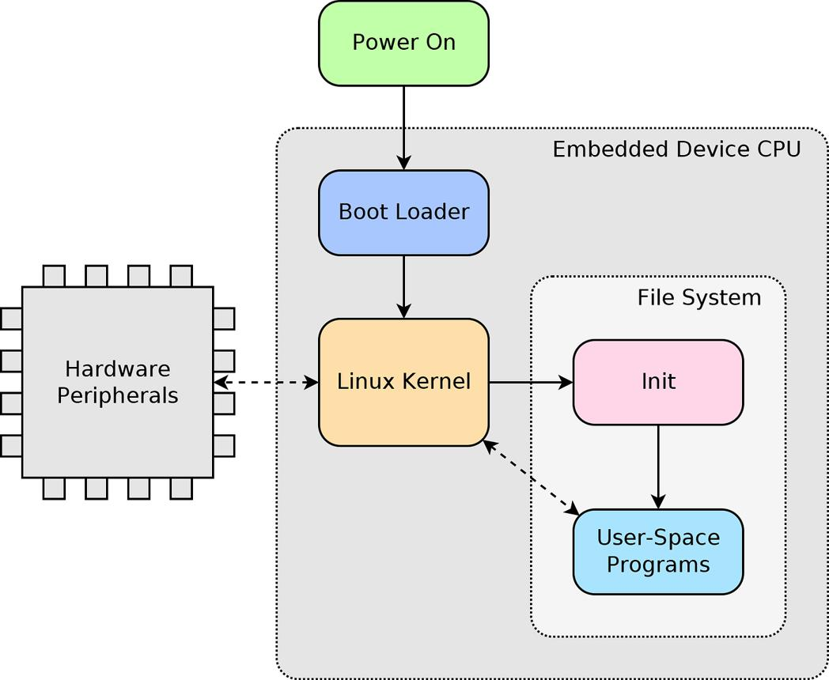
6
Raspberry Pi Boot Sequence
Power ON
↓
Boot ROM
↓
GPU Firmware
↓
config.txt
↓
Kernel Image
↓
Device Tree
↓
Root File System
↓
init/systemd
↓
User Applications

11. Kernel Module Development
Simple Driver:
#include <linux/module.h>
static int __init hello_init(void)
{
printk(KERN_INFO "Hello Driver\n");
return 0;
}
static void __exit hello_exit(void)
{
printk(KERN_INFO "Driver Removed\n");
}
module_init(hello_init);
module_exit(hello_exit);
MODULE_LICENSE("GPL");
Compile:
make
Insert:
sudo insmod hello.ko
Check:
dmesg | tail
Remove:
sudo rmmod hello

12. Embedded Linux Filesystem
Important directories:
/
├── bin
├── boot
├── dev
├── etc
├── home
├── lib
├── proc
├── root
├── sys
├── tmp
├── usr
└── var
Useful commands:
ls
pwd
mount
df -h
free -m
top
ps

13. Communication Interfaces
UART
sudo raspi-config
Enable Serial Port.
Device:
/dev/ttyAMA0

I2C
Enable:
sudo raspi-config
Install:
sudo apt install i2c-tools
Detect devices:
i2cdetect -y 1

SPI
Enable SPI:
sudo raspi-config
Check:
ls /dev/spidev*

14. Build Systems
Popular Embedded Linux Build Systems:
Tool | Purpose
Buildroot | Lightweight Linux generation
Yocto Project | Industrial Linux development
OpenEmbedded | Base layer for Yocto
BusyBox | Small command set

15. Typical Embedded Linux Development Flow
Hardware Selection
↓
Install Raspberry Pi OS
↓
Configure Network & SSH
↓
Cross Compiler Setup
↓
Application Development
↓
GPIO/I2C/SPI/UART Programming
↓
Kernel Driver Development
↓
Build Custom Kernel
↓
Build Root Filesystem
↓
Deploy & Test
Viva/Interview Questions
- What is Embedded Linux?
- What is a Device Tree?
- Difference between Bootloader and Kernel?
- What is Cross Compilation?
- What is GPIO?
- What is Device Driver?
- What is Buildroot?
- What is Yocto?
- Explain Raspberry Pi boot process.
- Difference between user space and kernel space?
These topics cover the complete Embedded Linux development workflow on Raspberry Pi typically expected in embedded systems labs, interviews, and project work.
Locate kernel image and find is size
To locate the Linux kernel image on a Raspberry Pi and find its size:
1. Locate the Kernel Image
Newer Raspberry Pi OS versions store kernel files in:
ls -lh /boot/firmware/kernel*
Older versions use:
ls -lh /boot/kernel*
Example output:
-rwxr-xr-x 1 root root 8.2M Jun 20 10:00 /boot/firmware/kernel8.img
Common kernel images:
File | Description
kernel.img | ARMv6/ARMv7 kernel
kernel7.img | 32-bit ARMv7 kernel
kernel7l.img | ARMv7 with LPAE
kernel8.img | 64-bit ARMv8 kernel

2. Find Kernel Image Size
Using ls:
ls -lh /boot/firmware/kernel8.img
Or using du:
du -h /boot/firmware/kernel8.img
Or exact size in bytes:
stat -c %s /boot/firmware/kernel8.img
Example:
8617984
which is approximately:
8617984 / 1024 / 1024 ≈ 8.22 MB

3. Find Currently Running Kernel Version
uname -r
Example:
6.12.34+rpt-rpi-v8

4. Verify Which Kernel Image is Being Used
Check /boot/firmware/config.txt:
grep "^kernel" /boot/firmware/config.txt
Example:
kernel=kernel8.img
If no kernel= line exists, the Raspberry Pi firmware automatically chooses the appropriate kernel image for the hardware.

For a lab/demo, a single command that shows both name and size is:
ls -lh /boot/firmware/kernel*
This lists all kernel images along with their sizes.
not rasberry pui, n eneral
On a general Linux system (not Raspberry Pi), you can locate the currently running kernel image and find its size as follows.
1. Check the Running Kernel Version
uname -r
Example:
6.8.0-60-generic

2. Locate the Kernel Image
Most distributions store kernel images in /boot.
ls /boot/vmlinuz*
Example:
/boot/vmlinuz-6.8.0-60-generic
To locate the kernel corresponding to the running version:
ls -l /boot/vmlinuz-$(uname -r)

3. Find the Kernel Image Size
Human-readable size:
ls -lh /boot/vmlinuz-$(uname -r)
Example:
-rw-r--r-- 1 root root 15M Jun 10 12:30 /boot/vmlinuz-6.8.0-60-generic
Exact size in bytes:
stat -c %s /boot/vmlinuz-$(uname -r)
or
du -h /boot/vmlinuz-$(uname -r)

4. Find All Installed Kernel Images and Their Sizes
ls -lh /boot/vmlinuz*
Example output:
-rw-r--r-- 1 root root 14M vmlinuz-5.15.0
-rw-r--r-- 1 root root 15M vmlinuz-6.8.0

5. Verify Kernel Image Used During Boot
On GRUB-based systems:
grep linux /boot/grub/grub.cfg
or
grep menuentry /boot/grub/grub.cfg
This shows which vmlinuz files are available for boot.
One-line Answer (often expected in labs)
ls -lh /boot/vmlinuz-$(uname -r)
This command displays the currently running kernel image and its size.

